**Q1**

**Q2**

**Q3**

**Q4**

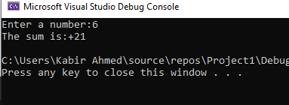

**Q5**

**Q6**

